# ALGO PROJECT

GROUP MEMBERS: 18K-1148, 17K-3786

# ABSTRACT:

This software is capable of solving classic problems like LCS, SCS, rod cutting etc by Dynamic programming approach. This project is made on visual studio 2019 using windows forms C++.

# INTRODUCTION:

This project uses C++ as its base language or backend language and Windows forms as its front end. There is a main/window which controls every other forms/windows like LCS, SCS, RODCUTTING, KNAPSACK etc. Algorithms used are

a. Longest Common Subsequence

b. Shortest Common Supersequence

c. Levenshtein Distance (edit-distance)

d. Longest Increasing Subsequence

e. Matrix Chain Multiplication (Order finding /paranthesization)

f. 0-1-knapsack-problem

g. Partition-problem

h. Rod Cutting Problem

i. Coin-change-making-problem

j. Word Break Problem

# SOME SCREEN SHOTS

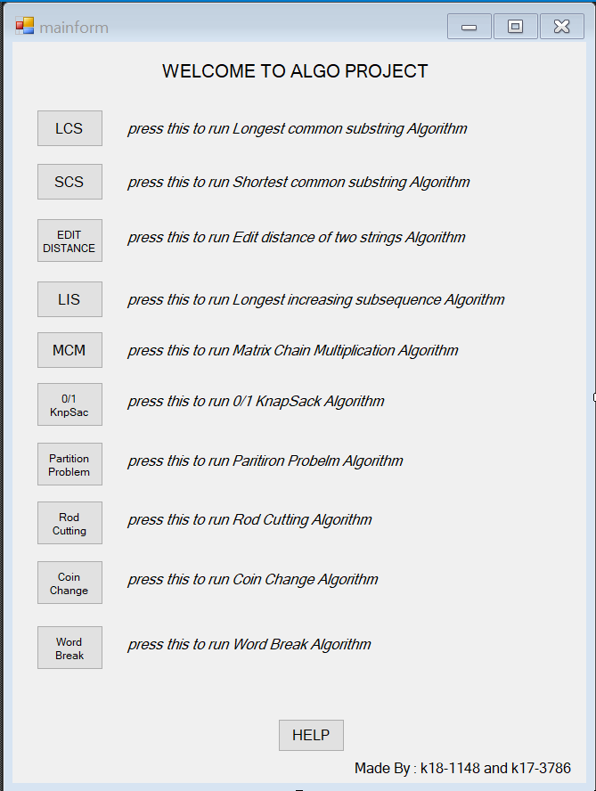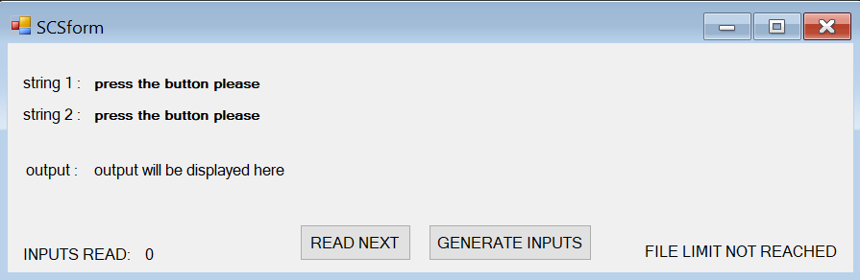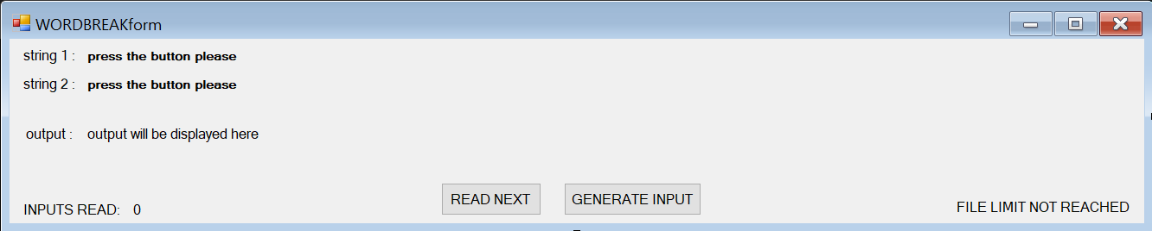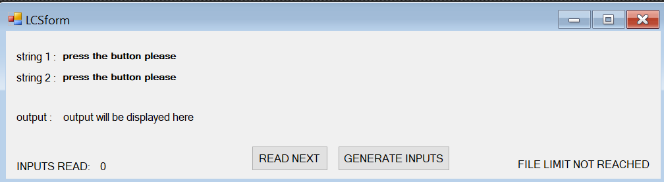

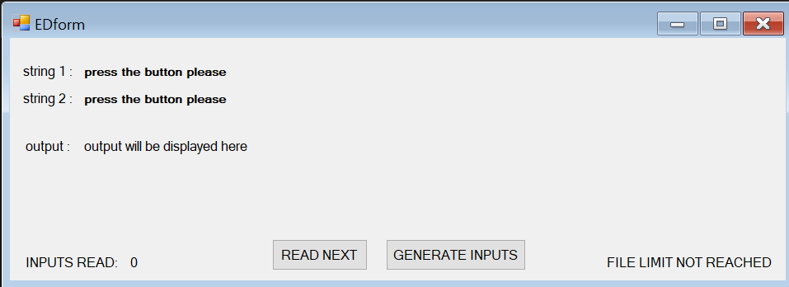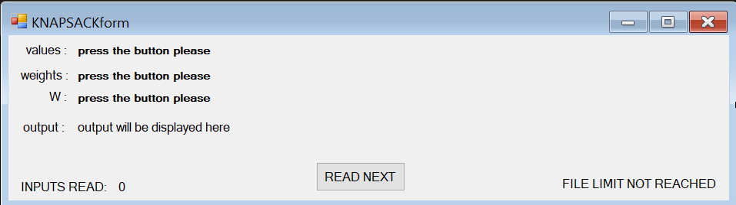

# EXPERIMENTAL SETUP (SAMPLES)

## Longest Common Subsequence:

Libraries

#include <fstream>

#include <iostream>

#include <string>

#include <stdlib.h>

#include <algorithm>

iraiaurauimazmrmdaarmuarmmrduilddaimrzhrmadar

hramzdadaizalaimiliiiimzmrrulmahmhhaaalzm

ruzmdrluahamizraiilrlazdmhdaammar

umahamuammiamdzaaamaamumliiazimumuzh

arlamamdaramzazmimlmmzzaaizahauluruurhrzzrd

iahraazmuiuumazmmmlmimiiuuulmmhadiairimm

halmhamazauaumdhmillmmmrmuaharmaumumrramaaaziu

dzamrdhddauimalamzdalmhllaarzaruhhhad

immazmudimudaalrulhaaddlamurah

iaralmiaaalalumahaaraauamuhruarmz

airralumzmdaaamdrmlzaumrrammaazmimrluaaz

arudhaidmhraarurmmzmdaammaamluaauamda

imadudrmmmamuzlimmuaziizrrdauradaa

uamilmzuzaiummmrrudiadmrmzamuuazii

aumiaaaduiamaaalzrzziiariuzmdmdraaaauhuau

mdiazmamuimzauhuaarahlaimamrhzmrimahmlhhmldmahmmhr

imiaammmludmmzzudhaumaiarummaduia

zazdmammzmzuaihidhlaurlmdidiardmlmmdaul

uuzahlmzmhmlmzmaalizuriaamlraamalama

aamurhauaraumuarzimuirdizadimaaiaii

## Shortest Common Supersequence:

Libraries

#include <fstream>

#include <iostream>

#include <string>

#include <stdlib.h>

#include <algorithm>

iazaurzaauaimmrziiummammmamaaazadiiamaadmudmzlm

duaammamdmzmihdazmmrrdaaaulaamah

lmmmiraiaalmhummaamumarimrzrrimuaaru

uzhaaaadmuhaadaaiiiazururmaualilu

hzazraarazlzrurmmmiuudamaazmlhzmzmrmmm

auazumhiaamzzmzarhzulaaiazammmuaarmuau

mmzmaalzammmhmhmmamaalauazmaiialmaidmmzaaz

aaidiuzmizauzmmuamammhdmuamalahammmuri

aummmmmmmzailzaamazazmadadiazrlmuaazuziralal

zaiazdluialrmaadzaruiizmuaidrmumiuiauhmummmramudrul

rmuimuaimhuimuduazaulirmrzmuiaauulammmaimumulm

mzhudamaariamlrulaazimmzahaaziamumaauhuudamraar

ralhzmziaimaaraidmairzrdaazhuaradmm

aiiumzamdzrazuaaahzmiazialrrmrr

mmmamazuizuzhiauilmahzmrzrmdaammuamzuzr

araammmrummaumruhaiuuhamrmhmaiaumiaazami

iumzarrziumdirilmlhahauuaidmaaarza

rlummzaaraaalzaaamaamrzrmhazmaamlriam

zdaaalhmahlzmlzaaualarlamharmaamaahrhmru

izizamurdammdaauzmmmaaazraaamazh

## Levenshtein Distance (edit-distance):

Libraries

#include <fstream>

#include <iostream>

#include <string>

#include <stdlib.h>

#include <algorithm>

ialamaarzaurilmaamlramaammizuaahmma

hmmrimauziaumhamarizrmiahmzuarzmaaimaauramamazurdh

hmlidmmzlualzziaarmiairmamzimraamiimm

iuiuzmliamazrirrzmduzazamuzuuaazizd

raahzaamrazdmziuiuhaazmhluizdaamizma

riuuaamaaariiamaailluidmazrurahiruizhmmdum

dzammrimzaummihlzrimzmamamzurzim

mzmazzuaumlirauaraaazauraralrmmhim

haizulazzaaaaliaaimzmdamammmmmaazazmuaz

lmmzirrmzaizhuriizaiadziuaauzaimllima

iazmziziuaimmahariaiadaaimaiiia

aammrmamuuarlzraziziuhaarimziiazahamazarula

ruuudulhlizrhhamallrhdmllruimmmzmluihzaa

ramzaaizzazrzlmrlriuuuauamhahaamazmmrrhaaizdr

armiuzumlzhrluuuiamaauhmuaraalimmlhmaliaumaam

iaiumaiiahrummamarzmmaaaiauzzmrihmz

dlaamiuhzmzmraarzhuiaairrmdiizmaimamumuaiar

mlzaaaaumzaiumuuiairmzamiammmlmaard

ihhuiluzarzrrmzuuimuarhaaliamzlmrumalzaauaurmadaimuzaaaa

hllzhamlaazhamuaaaiiarmamhzmmaaidazzm

## Longest Increasing Subsequence:

Libraries

#include <fstream>

#include <iostream>

#include <string>

#include <stdlib.h>

#include <algorithm>

42,13,23,4,57,23,90,91,22,47,9,30,3,22,20,73,85,92,34,90,90,62,7,18,91,15,92,55,86,63,70,13,36,39,94,

31,87,59,44,12,93,59,15,42,42,4,52,53,16,13,52,76,92,80,91,34,26,93,19,16,76,66,74,0,72,49,7,49,22,52,25,60,

43,6,64,82,60,19,89,63,37,17,6,85,81,73,74,13,34,89,31,77,51,9,96,10,7,18,44,83,0,2,4,97,53,

77,73,42,20,47,33,23,49,39,22,47,64,68,52,49,31,76,60,40,3,72,73,54,71,29,68,89,49,53,88,41,5,4,95,71,

7,10,58,31,81,84,8,56,43,38,92,21,15,56,69,64,66,19,10,27,78,32,28,70,80,34,77,98,75,19,

63,28,19,70,87,39,18,14,84,41,57,64,28,45,69,42,56,12,99,23,5,6,45,65,24,76,42,21,80,60,1,

87,46,60,88,34,18,19,59,9,13,26,63,92,21,59,62,74,26,79,72,98,9,0,85,53,21,56,54,77,17,27,12,7,83,97,71,46,91,70,

46,25,31,12,80,73,72,0,89,49,15,76,94,65,90,53,34,89,55,40,71,19,81,59,86,79,80,46,54,83,57,19,50,23,88,74,18,26,

43,53,8,65,54,37,7,27,70,3,7,45,32,50,94,52,0,13,66,9,4,30,15,48,76,24,89,37,21,62,92,59,33,62,33,

63,81,66,10,27,54,37,7,71,63,81,0,71,45,95,28,33,34,56,67,64,27,77,56,97,13,74,78,23,4,69,43,

## Matrix Chain Multiplication:

Libraries

#include <fstream>

#include <iostream>

#include <string>

#include <stdlib.h>

#include <algorithm>

19,9,82,2,10,70,23,49,18,82,55,44,86,93,68,12,54,55,54,14,33,71,24,6,83,3,75,5,52,53,30,7,7,96,37,46,31,16,22,61,18,94,91,

64,98,89,91,14,14,19,65,68,8,51,30,49,96,75,94,74,71,69,48,34,38,15,64,98,19,71,48,77,81,52,8,90,40,87,22,49,

63,4,10,80,94,31,11,91,79,40,52,7,25,19,19,39,98,51,56,87,29,13,76,67,77,59,67,29,44,10,42,10,72,65,26,82,

53,27,51,44,85,14,20,2,76,31,94,61,45,89,87,77,51,77,84,64,75,31,13,70,79,8,91,14,47,79,19,22,30,55,33,35,22,10,79,90,97,

24,81,9,59,20,59,80,32,60,88,97,57,94,13,92,40,45,8,90,17,48,50,26,48,73,65,20,0,26,67,53,49,36,17,4,7,67,30,49,21,

60,21,35,50,73,82,44,84,97,66,47,40,6,57,60,44,35,35,31,21,61,25,56,96,78,32,98,35,5,49,91,54,80,22,19,23,25,

24,55,62,14,92,34,86,48,56,89,60,76,99,63,72,97,92,48,87,4,21,76,36,75,97,90,25,36,42,57,79,16,56,30,49,60,60,57,

30,97,71,82,41,27,41,65,43,92,83,48,27,32,13,13,7,25,84,43,76,46,94,22,17,99,22,41,49,2,58,54,16,52,62,50,42,22,60,58,76,93,51,15,

52,15,2,70,46,38,76,84,56,81,33,60,55,50,67,47,40,72,71,78,82,6,86,64,98,81,7,60,53,89,18,77,70,1,91,45,46,78,13,

96,35,55,42,94,59,79,49,64,67,91,56,8,27,25,43,64,43,46,45,31,92,94,86,30,75,5,75,88,82,11,34,59,88,25,19,

## 0-1-knapsack-problem:

Libraries

#include <fstream>

#include <iostream>

#include <string>

#include <stdlib.h>

#include <algorithm>

5,12,32,34,45,55,65,76,77,87,88,89,90,93,95,97,99,

10,20,30,34,35,36,37,45,47,55,56,57,58,68,69,78,79,

148

1,3,5,6,9,15,16,19,24,27,28,34,36,39,56,75,78,89,99,

10,13,15,16,17,18,19,22,24,27,28,34,36,39,56,75,78,89,99,

148

1,3,5,6,9,15,16,19,24,27,28,34,36,39,56,75,78,89,91,93,94,96,

10,13,15,16,17,18,19,22,24,27,28,34,36,39,56,75,78,89,94,96,97,98,

148

1,3,5,6,9,15,17,20,23,24,27,28,34,36,39,56,75,78,89,99,

10,13,15,16,17,18,19,20,22,24,27,28,34,36,39,56,75,78,89,99,

148

1,3,5,6,9,10,12,14,15,16,19,24,27,28,34,36,39,56,75,78,89,99,

1,3,6,10,13,15,16,17,18,19,22,24,27,28,34,36,39,56,75,78,89,99,

148

1,3,5,6,9,15,16,19,24,27,28,34,36,39,56,60,64,68,69,70,75,78,89,99,

1,2,4,5,6,10,13,15,16,17,18,19,22,24,27,28,34,36,39,56,75,78,89,99,

148

1,3,5,6,9,15,16,19,24,27,28,34,36,39,56,75,78,89,99,

10,13,15,16,17,18,19,22,24,27,28,34,36,39,56,75,78,89,99,

148

1,3,5,6,9,15,16,19,24,27,28,34,36,39,43,44,45,49,55,56,75,78,89,99,

10,13,15,16,17,18,19,22,24,27,28,34,36,39,43,44,45,46,47,56,75,78,89,99,

148

1,3,5,6,9,15,17,20,23,24,27,28,34,36,39,56,75,78,89,99,

10,13,15,16,17,18,19,20,22,24,27,28,34,36,39,56,75,78,89,99,

148

1,3,5,6,9,15,16,19,24,27,28,34,36,39,56,75,78,89,99,

10,13,15,16,17,18,19,22,24,27,28,34,36,39,56,75,78,89,99,

148

## Partition-problem:

Libraries

#include <fstream>

#include <iostream>

#include <string>

#include <stdlib.h>

#include <algorithm>

40,59,40,17,7,54,43,94,26,51,56,74,70,14,55,0,47,29,98,97,58,76,3,36,45,99,87,13,3,87,74,41,25,49,16,93,70,83,65,

54,37,88,8,71,49,52,16,98,83,71,18,74,63,31,20,44,35,55,58,86,65,69,60,90,13,81,86,19,95,73,79,89,67,36,63,

76,50,10,52,91,59,52,4,54,77,6,14,92,36,61,85,50,35,50,49,99,98,59,47,8,58,78,40,76,17,34,10,1,40,95,66,

5,49,42,80,12,96,64,19,69,38,64,55,82,4,7,69,88,29,87,4,48,13,28,10,82,49,2,19,9,20,88,53,44,81,14,55,69,

94,14,4,94,17,38,66,84,47,2,41,83,75,46,43,59,59,15,13,58,95,87,22,44,46,14,49,43,52,18,51,12,47,17,98,

66,0,98,44,63,86,92,63,55,56,25,79,22,45,20,61,99,45,64,96,30,56,62,32,88,72,63,59,57,86,27,56,15,2,82,87,69,2,86,11,

21,6,54,29,50,3,67,93,21,64,61,85,97,24,90,77,11,94,44,17,58,32,29,62,88,59,84,76,15,44,82,18,9,53,78,28,65,

19,85,46,98,90,83,60,84,68,56,81,71,8,7,97,21,28,57,84,15,42,95,38,83,15,4,43,70,75,92,11,68,62,54,5,95,14,23,

85,94,71,73,6,42,54,82,83,36,45,36,20,17,20,50,25,62,81,53,86,84,9,33,51,89,24,99,37,33,78,3,23,6,90,7,58,45,90,32,46,43,41,35,

37,7,40,8,69,8,17,3,98,27,37,14,76,91,32,26,57,41,80,59,25,7,55,86,69,68,42,80,59,93,39,99,64,91,36,92,71,39,79,60,63,64,96,1,44,25,

## Rod Cutting Problem:

Libraries

#include <fstream>

#include <iostream>

#include <string>

#include <stdlib.h>

#include <algorithm>

5,12,32,34,45,55,65,76,77,87,88,89,90,93,95,97,99,

10,20,30,34,35,36,37,45,47,55,56,57,58,68,69,78,79,

14

1,3,5,6,9,15,16,19,24,27,28,34,36,39,56,75,78,89,99,

10,13,15,16,17,18,19,22,24,27,28,34,36,39,56,75,78,89,99,

148

1,3,5,6,9,15,16,19,24,27,28,34,36,39,56,75,78,89,91,93,94,96,

10,13,15,16,17,18,19,22,24,27,28,34,36,39,56,75,78,89,94,96,97,98,

148

1,3,5,6,9,15,17,20,23,24,27,28,34,36,39,56,75,78,89,99,

10,13,15,16,17,18,19,20,22,24,27,28,34,36,39,56,75,78,89,99,

148

1,3,5,6,9,10,12,14,15,16,19,24,27,28,34,36,39,56,75,78,89,99,

1,3,6,10,13,15,16,17,18,19,22,24,27,28,34,36,39,56,75,78,89,99,

148

1,3,5,6,9,15,16,19,24,27,28,34,36,39,56,60,64,68,69,70,75,78,89,99,

1,2,4,5,6,10,13,15,16,17,18,19,22,24,27,28,34,36,39,56,75,78,89,99,

148

1,3,5,6,9,15,16,19,24,27,28,34,36,39,56,75,78,89,99,

10,13,15,16,17,18,19,22,24,27,28,34,36,39,56,75,78,89,99,

148

1,3,5,6,9,15,16,19,24,27,28,34,36,39,43,44,45,49,55,56,75,78,89,99,

10,13,15,16,17,18,19,22,24,27,28,34,36,39,43,44,45,46,47,56,75,78,89,99,

148

1,3,5,6,9,15,17,20,23,24,27,28,34,36,39,56,75,78,89,99,

10,13,15,16,17,18,19,20,22,24,27,28,34,36,39,56,75,78,89,99,

148

1,3,5,6,9,15,16,19,24,27,28,34,36,39,56,75,78,89,99,

10,13,15,16,17,18,19,22,24,27,28,34,36,39,56,75,78,89,99,

148

## Coin-change-making-problem:

Libraries

#include <fstream>

#include <iostream>

#include <string>

#include <stdlib.h>

#include <algorithm>

69,12,66,85,14,38,44,5,95,78,6,98,45,38,83,28,45,29,19,91,78,20,21,80,72,7,46,23,25,45,32,78,72,4,19,28,57,38,79,71,38,91,12,

148

51,33,19,89,27,75,3,51,0,10,53,30,49,61,48,57,30,58,1,11,51,90,80,6,25,10,29,44,71,15,12,25,22,79,93,90,57,18,9,97,35,87,35,

148

92,74,54,78,30,63,63,56,17,46,95,14,22,23,25,70,14,77,72,13,16,71,37,66,55,75,92,1,66,18,75,34,37,70,40,67,75,96,79,33,30,22,27,

148

2,67,70,68,0,51,24,27,54,23,43,33,44,85,38,44,0,50,13,48,62,30,43,8,17,22,35,77,79,88,40,67,33,43,64,

148

54,85,9,77,3,79,22,18,0,9,83,42,57,23,65,69,94,71,58,84,93,47,83,39,44,83,66,47,44,8,9,5,43,6,89,49,99,

148

5,95,67,10,57,63,89,64,39,81,98,82,81,48,1,63,33,82,32,44,10,88,9,48,41,48,49,40,40,12,92,99,50,90,35,8,34,58,77,

148

53,77,4,75,18,39,61,17,64,7,27,23,1,7,69,53,24,45,14,88,43,6,65,26,27,60,87,43,18,45,15,23,47,25,37,2,35,72,51,19,92,49,75,29,57,84,

148

91,61,44,24,5,0,14,25,68,65,12,9,76,50,78,71,97,95,4,33,60,94,57,59,92,48,40,16,15,69,62,14,63,92,97,

148

13,66,29,68,37,39,43,65,74,80,59,35,28,90,67,71,86,61,67,82,25,31,43,39,77,26,61,15,95,63,52,27,39,24,50,34,68,87,95,96,43,17,55,77,96,60,72,52,78,24,58,4,50,

148

34,88,60,73,51,16,19,65,76,92,26,36,92,85,19,60,58,34,57,56,79,81,48,44,11,68,42,69,35,21,59,11,82,50,42,29,59,21,30,68,40,13,51,32,51,

148

## Word Break Problem:

Libraries

#include <fstream>

#include <iostream>

#include <string>

#include <stdlib.h>

#include <algorithm>

nkp,rtes,madg,l,vob,qmh,tys,a,b,mk,sdh,g,gcvc,pt,tj,jit,usllq,mw,xyv,yw,gmt,vi,rlf,hylb,d,ffra,fv,abqr,ve,ex,bsnb,g,r,eh,idl,

mirzamuhammaduzairali

i,rha,ycf,i,gesdq,mtjun,jye,j,p,c,wae,ywe,wcgg,wqdt,o,wf,onwuu,q,is,y,exlc,e,wtw,xg,ybra,bw,sl,j,s,wd,wt,cgop,ai,ucj,k,gp,

mirzamuhammaduzairali

n,pgy,v,ot,jyd,kfqs,b,k,b,wogoh,hm,vmp,t,bsx,lg,fda,rr,uni,j,i,vc,dpw,djyr,x,ibyl,pfe,fr,vtt,ov,ngor,pp,kojn,un,

mirzamuhammaduzairali

foxd,b,f,xk,cw,y,g,d,pom,gjd,a,gma,yqb,dntk,juq,ou,cu,yqnxa,iyx,nokf,enstg,ob,sw,lm,dp,xvx,dyu,h,k,qg,g,rclq,

mirzamuhammaduzairali

g,a,ixqya,vgi,kxp,mk,gx,spa,rjmr,ued,v,jnb,nnd,wy,awvl,pk,s,uu,uah,bk,rbw,g,jwyih,qyfe,k,cau,g,buca,wcr,mj,

mirzamuhammaduzairali

c,srrsn,yda,emjt,clpa,ym,uvp,yi,wbij,cvc,v,ab,kgkw,hxjw,h,voaw,vjmdh,r,onhm,ch,dte,wrw,c,ou,quln,in,stvu,rss,fsu,mn,xf,xhkf,gcjp,

mirzamuhammaduzairali

y,hlm,qofc,uyo,tsqj,fcaj,bca,a,ihhi,whdd,q,f,nd,vfp,hs,stl,m,s,h,mun,yek,oigt,tcq,olq,pihi,qhl,cicr,tjs,qvvw,nko,xd,tmdf,tocng,yh,wsma,yjae,xot,ao,

mirzamuhammaduzairali

fb,dml,cw,gpf,oj,m,tgb,ne,eor,go,xdkli,cbxs,xw,ddw,cdho,kygys,r,rxht,id,gi,os,c,bdk,o,diu,vj,yifl,giij,xpjb,wgl,ru,om,e,l,b,

mirzamuhammaduzairali

n,urq,rk,ebs,y,onyv,oe,j,kp,fr,mahh,gw,jaw,md,vp,lkgl,hks,rku,nk,sfwc,vosj,ad,t,gxv,wwj,m,spq,pbfv,jb,nqrk,dth,pwbb,o,ml,vi,llu,m,vmvbg,

mirzamuhammaduzairali

wdd,taut,fd,hw,pb,vtfm,m,ym,c,t,dfpru,vn,fm,p,kpjf,g,yhm,sub,tnvj,tjin,mj,imhe,p,ux,lr,ik,sl,id,gjyx,jw,rvlx,mym,yhb,yh,c,

mirzamuhammaduzairali

# RESULTS AND DISCUSSION

(SCREEN SHOTS)

LCS EXAMPLE

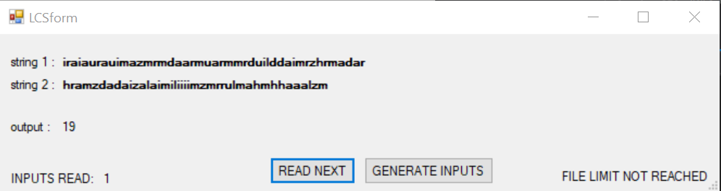

SCS EXAMPLE

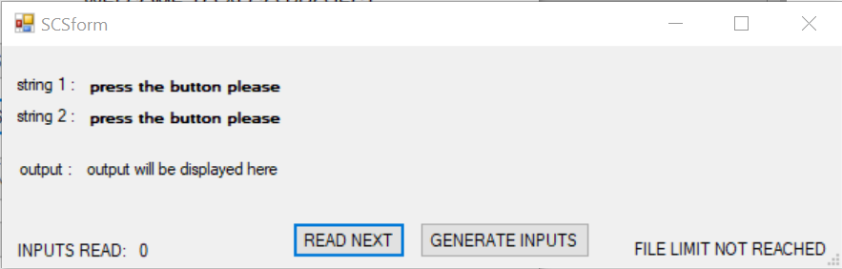

EDIT DISTANCE EXAMPLE

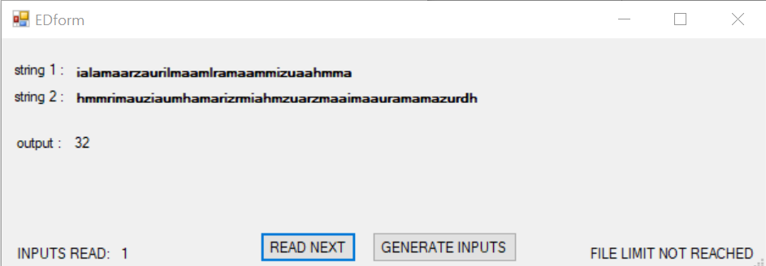

LIS EXAMPLE

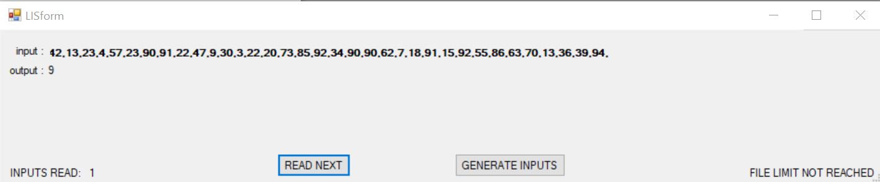

MATRIX CHAIN MULTIPLICATION EXAMPLE

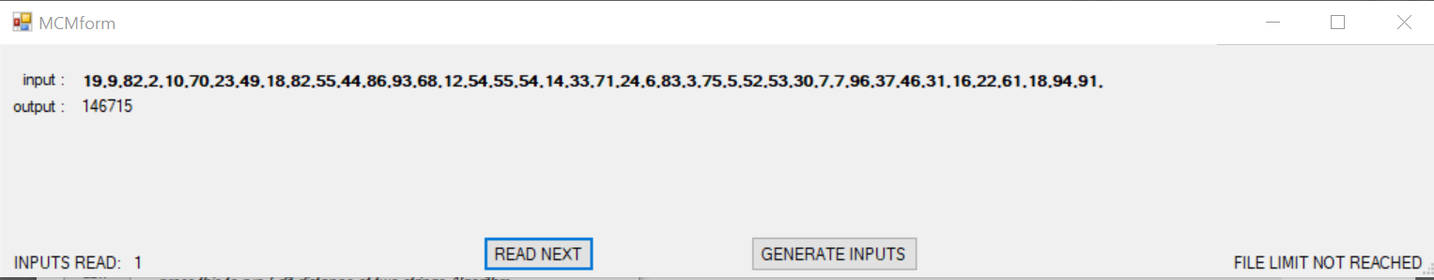

0/1 KNAPSACK EXAMPLE

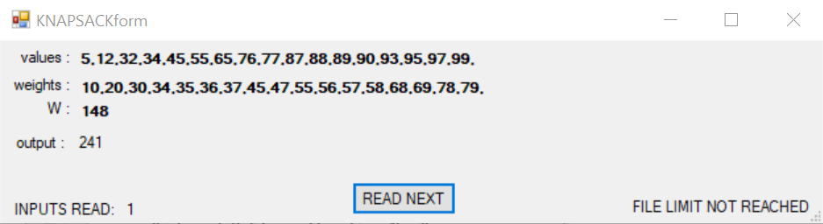

PARTITION PROBLEM

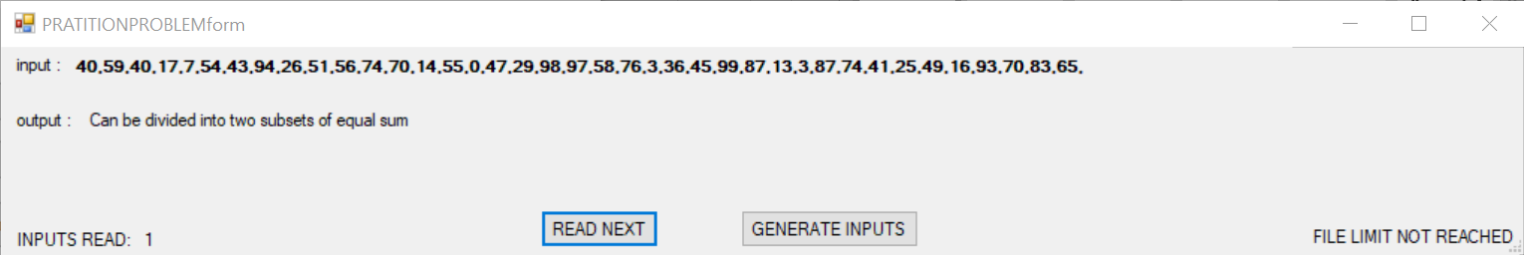

ROD CUTTING EXAMPLE

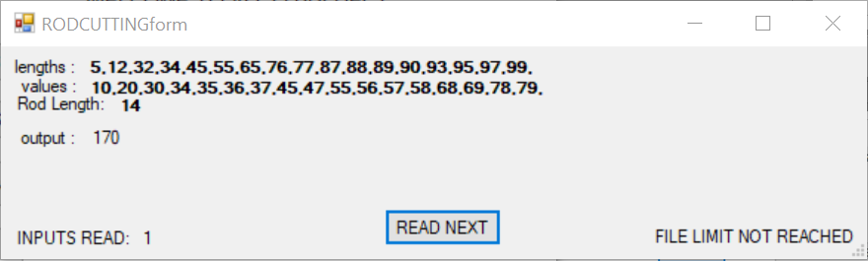

COIN CHANGE EXAMPLE

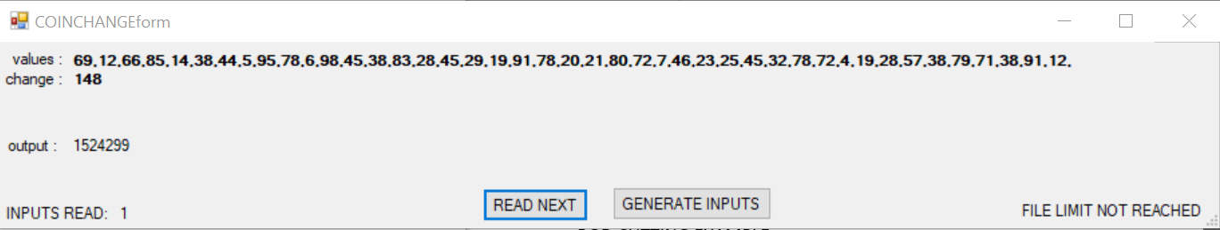

WORD BREAK EXAMPLE

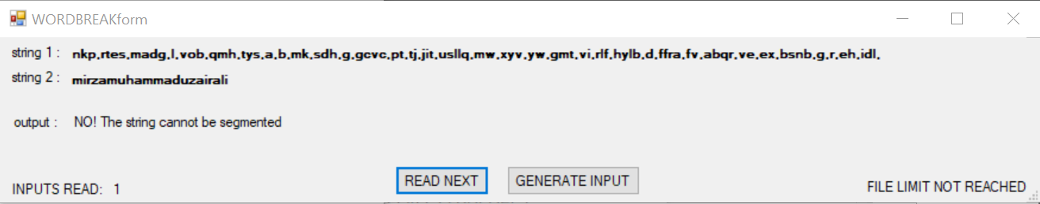

# CONCLUSION

This project taught me a lot of stuff like GUI programming, how to tackle different string problems, and solve the classic problem like SCS, LCS, ROD CUTTING, 0/1 KNAPSACK etc using dynamic programming and c++

# REFERANCES

* <https://visualstudio.microsoft.com/downloads/>
* <https://www.geeksforgeeks.org/>
* <https://stackoverflow.com/>